**Integrating Web3 Features into Moodle**

Urban Vidoviˇc(B), Vid Kerˇsiˇc, and Muhamed Turkanovi´c Faculty of Electrical Engineering and Computer Science, University of Maribor, 2000 Maribor, Slovenia

* Approach: Moodle plugin is a bridge between client, EduCTX blockchain network (<https://platform.eductx.org>) and the moodle server
* MetaMask browser extension needed

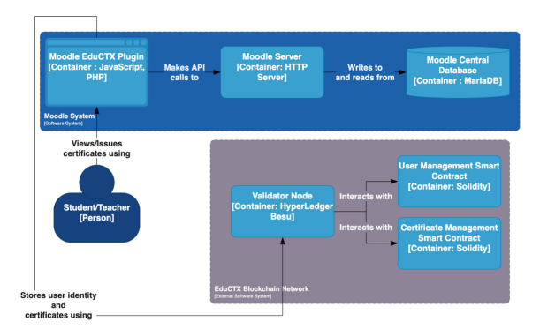

* EduCTX
* Smart contracts store the certificates and users’ identities and present the “back-end” of the system
* Moodle system
* consists of an Apache HTTP server, MariaDB database, and the proposed EduCTX plugin
* Server hosts the Moodle platform and communicates Database

Teacher’s Workflow

* teacher connects MetaMask wallet to the plugin and issues the certificate
* plugin takes student’s public key from EduCTX, encrypts the certificate and hashes the certificate
* plugin stores encrypted certificate and its hash on the EduCTX blockchain network
* certificate encryption is carried out entirely on the client-side, that no critical data leaves the teacher’s device
* certificate can only be decrypted by the student using private key

Student’s Workflow

* MetaMask Wallet of student establishes connection with the plugin
* Student can take certificate from EduCTX
* student exports the private key from the MetaMask wallet and fills it into an input field
* all certificates are decrypted and presented in a table upon clicking on the decrypt button
* export certificate with EduCTX

Verifier’s Workflow

* does not require the usage of plugin since EduCTX aims to enable anyone to verify certificates
* anyone can visit the platform and verify any EduCTX-based credential without the need of having a wallet set up

Plugin

* in PHP and Java Script

**Developing Ethereum Blockchain-Based Document Verification Smart Contract for Moodle Learning Management System**

Erinç KARATAŞ 1 1Computer Technologies Department, Elmadag Vocational School, Ankara University, Ankara, Türkiye

* Approach: application with use of smart contracts in Moodle
* smart contract in which the certificate information could be stored on the Ethereum blockchain
* Ethereum blockchain has to be installed
* Write Ethereum-based smart contract -> Solidity language
* Send smart contract to the blockchain
* Smart contract consist of two main functions
* Write name, surname, identity information of the participant, the institution issuing the certificate, document authentication code and hash value of the document
* using document authentication code to verify participant's digital certificate
* students click on a link to download their certificate
* students are registered into the Ethereum block chain by running a smart contract

**The Open University’s repository of research publications and other research outputs**

**A case study on the decentralisation of lifelong learning using blockchain technology**

* Approach: Semantic Blockchain

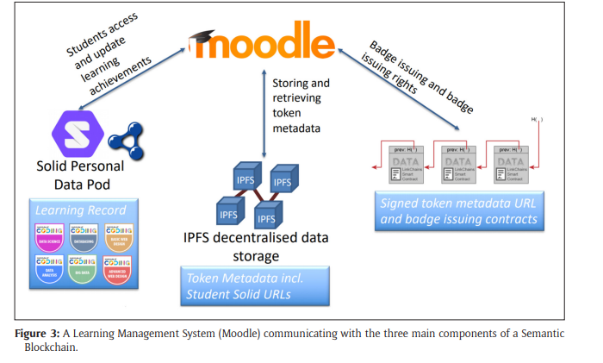

* Solid Personal Data Pod belongs to student (holder) with learning record
* Student has access to moodle to get learning certificates from moodle
* IPFS (Interplanetary File System) stores students documents with “token metadata?” and Student Solid URLs
* Moodle issues badges and badge issuing rights to the blockchain
* On Blockchain: signed token metadata URL and badge issuing contracts